DAVID Y. IGE  GOVERNOR | 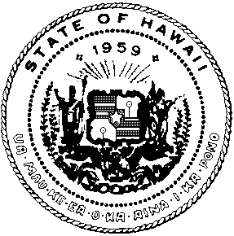  STATE OF HAWAII  DEPARTMENT OF HUMAN SERVICES  Office of the Director  P. O. Box 339  Honolulu, Hawaii 96809-0339  Date | PANKAJ BHANOT  DIRECTOR  CATHY BETTS  DEPUTY DIRECTOR
December 28, 2018

MEMORANDUM:

TO: The Honorable David Y. Ige, Governor
State of Hawaii

FROM: Pankaj Bhanot
Director

SUBJECT: DELEGATION OF AUTHORITY FOR THE CERTIFICATION OF ASSURANCES FOR THE LOW-INCOME HOME ENERGY ASSITANCE PROGRAM (LIHEAP)

We are requesting that you delegate authority to the Low-Income Home Energy Assistance Program (LIHEAP) office in the Department of Human Services to sign on your behalf that the State will comply with the 16 LIHEAP Assurances continued in Title XXVI of the Omnibus Budget Reconciliation Act of 1981. A copy of the Assurances is attached.

The regulations require that the Assurances are to be signed by the Chief Executive Officer, unless authority is delegated to another, and submitted with the annual request for LIHEAP funds.

We request delegation in order to expedite the requests for any and all annual requests for funds. LIHEAP in Hawaii annually provides heating credits to approximately 8500 electric and gas utility accounts of low-income applicants, and prevents households from having their power terminated.

If you have any questions, please contact Program Specialist and TA-LIHEAP Coordinator,
Elisa Furtado-Fischer of the Benefit, Employment and Support Services Division,
at 586-5734.

Attachment

